Source: https://www.bbc.com/indonesia/majalah/2016/09/160929_majalah_trenggiling_ilegal

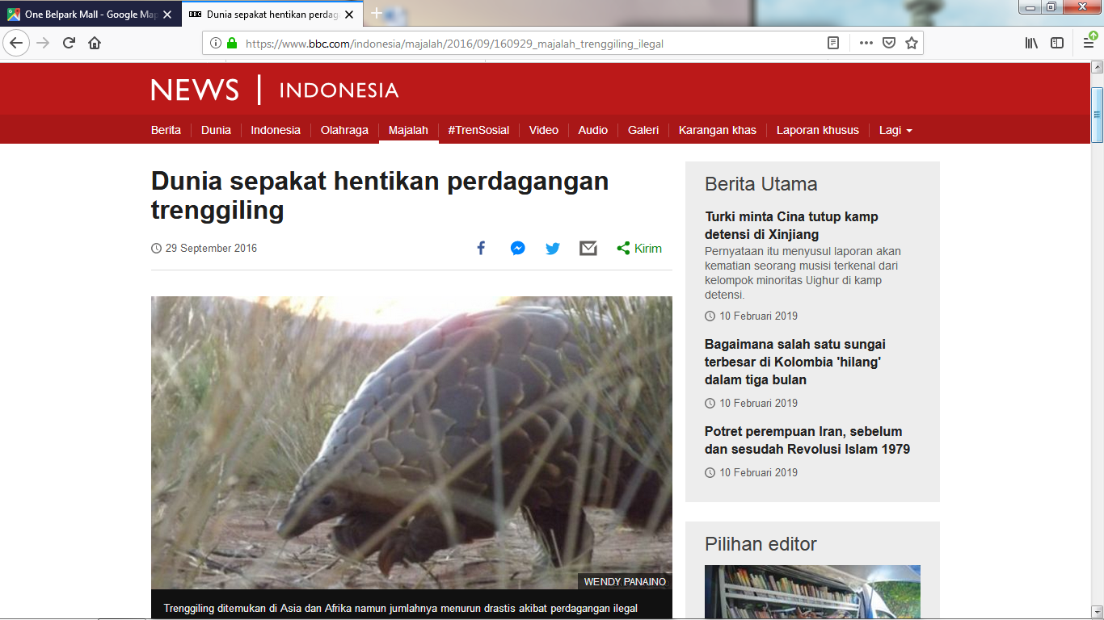

More source: https://www.greeners.co/flora-fauna

Source: https://www.greeners.co/flora-fauna/trenggiling-jawa-si-manis-yang-terancam-punah/
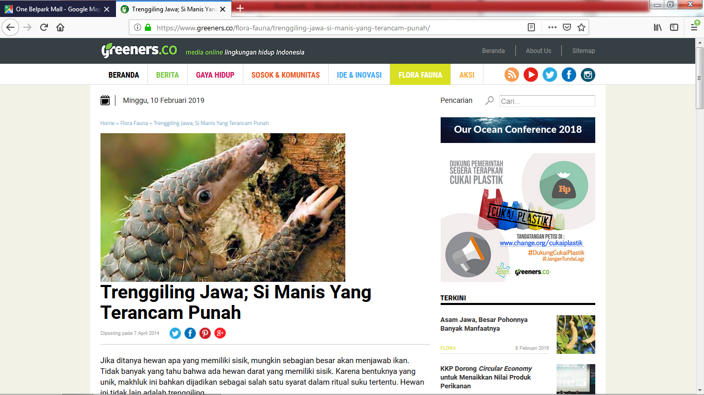

Source: https://news.detik.com/berita/d-3710174/ini-alasan-trenggiling-di-sumatera-terus-diburu
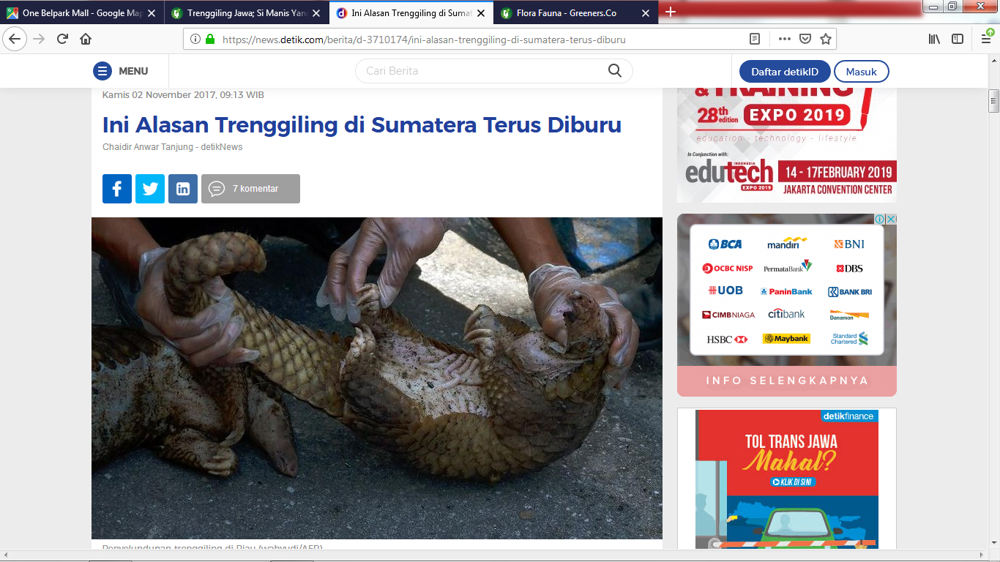

Source: https://www.worldwildlife.org/species/pangolin
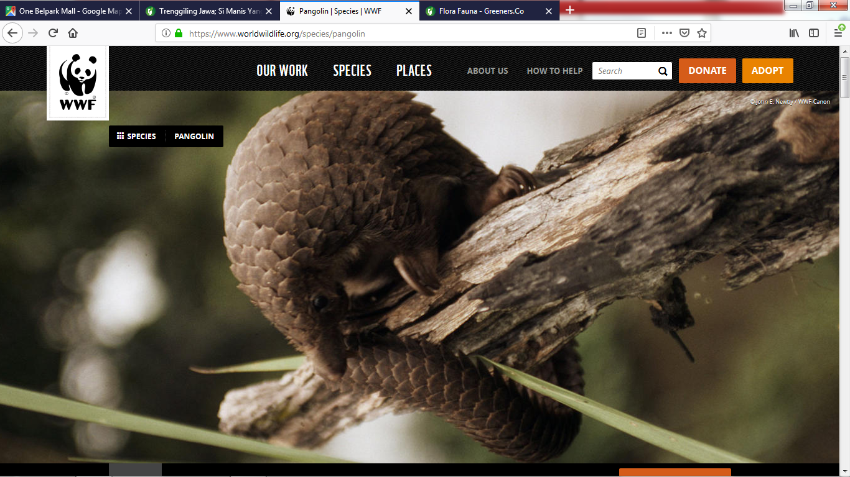

Source: https://blogs.uajy.ac.id/renitanurhayati/2015/12/03/upaya-pelestarian-trenggiling-manis-javanica/

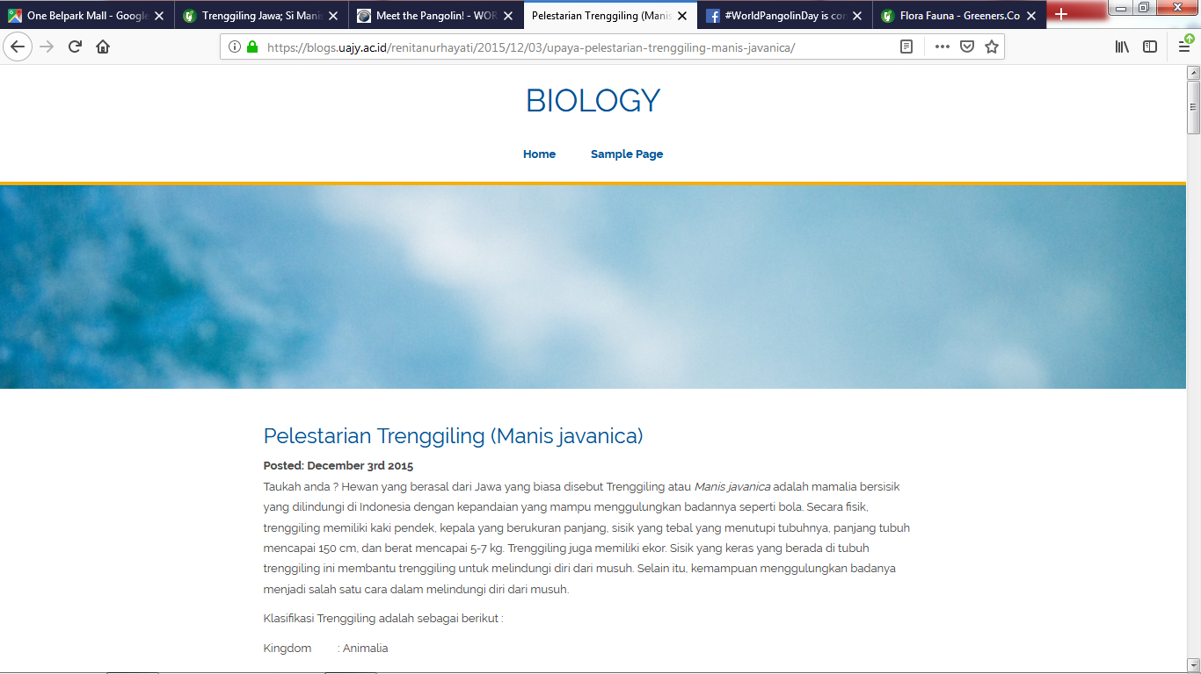

Source: https://ilmugeografi.com/biogeografi/cara-melestarikan-flora-dan-fauna
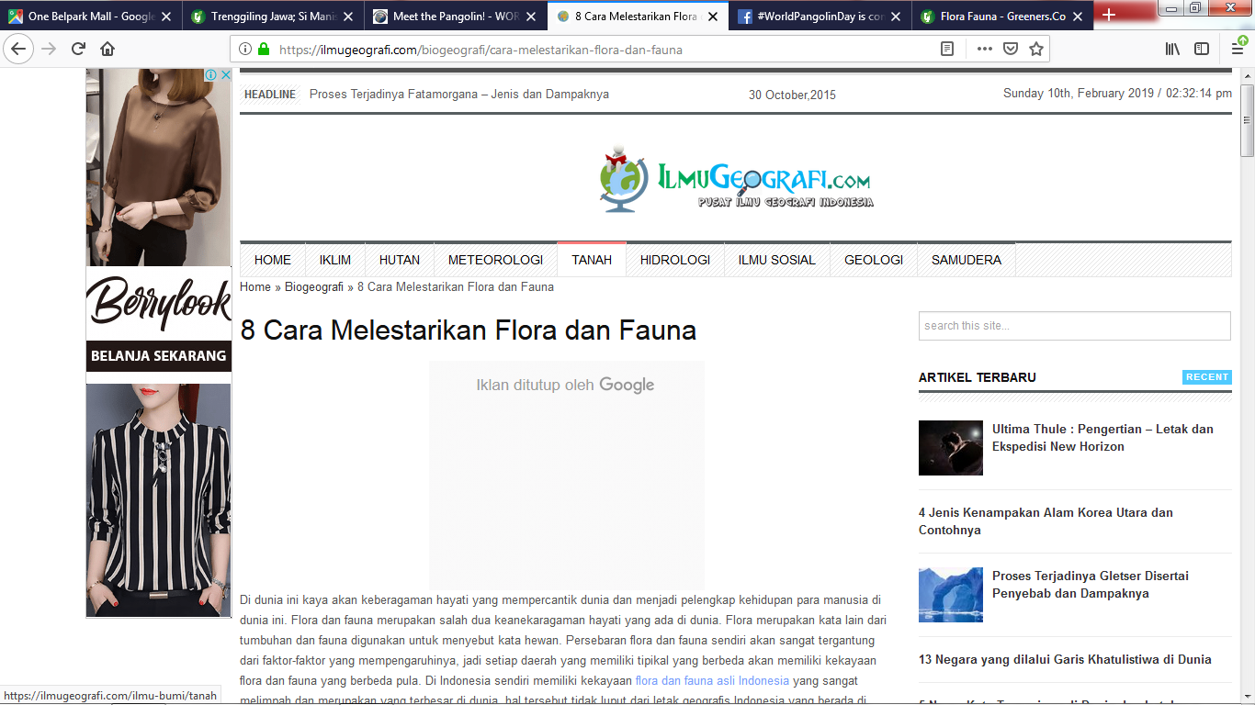

Source: https://www.pangolins.org/

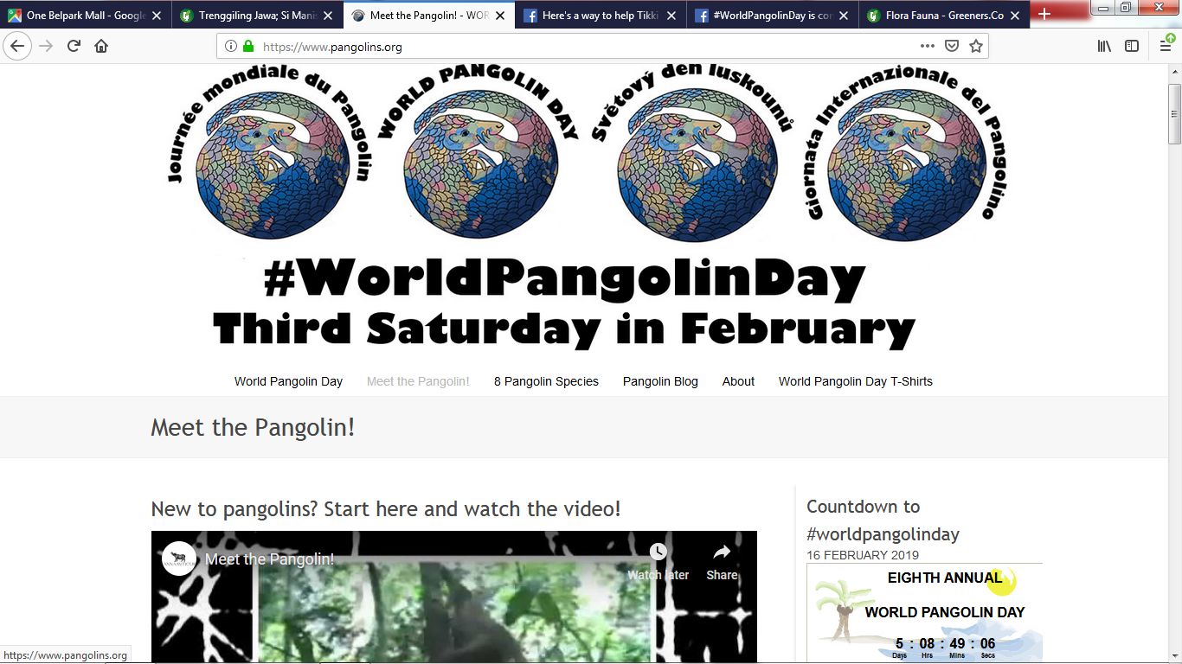

(must source of pangolins)
#worldpangolindayiscoming
#lovepangolins

