February
2019
Title  In 17 of febuary 2019 there is apangolin day  so get ready to save pangolins | 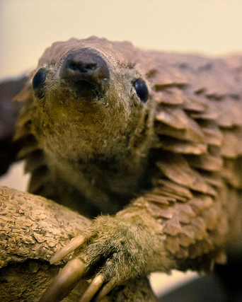
Sunday | Monday | Tuesday | Wednesday | Thursday | Friday | Saturday
 |  |  |  |  | 1 | 2
3 | 4 | 5 | 6 | 7 | 8 | 9
10 | 11 | 12 | 13 | 14 | 15 | 16
17 | 18 | 19 | 20 | 21 | 22 | 23
World pangolin day
24 | 25 | 26 | 27 | 28

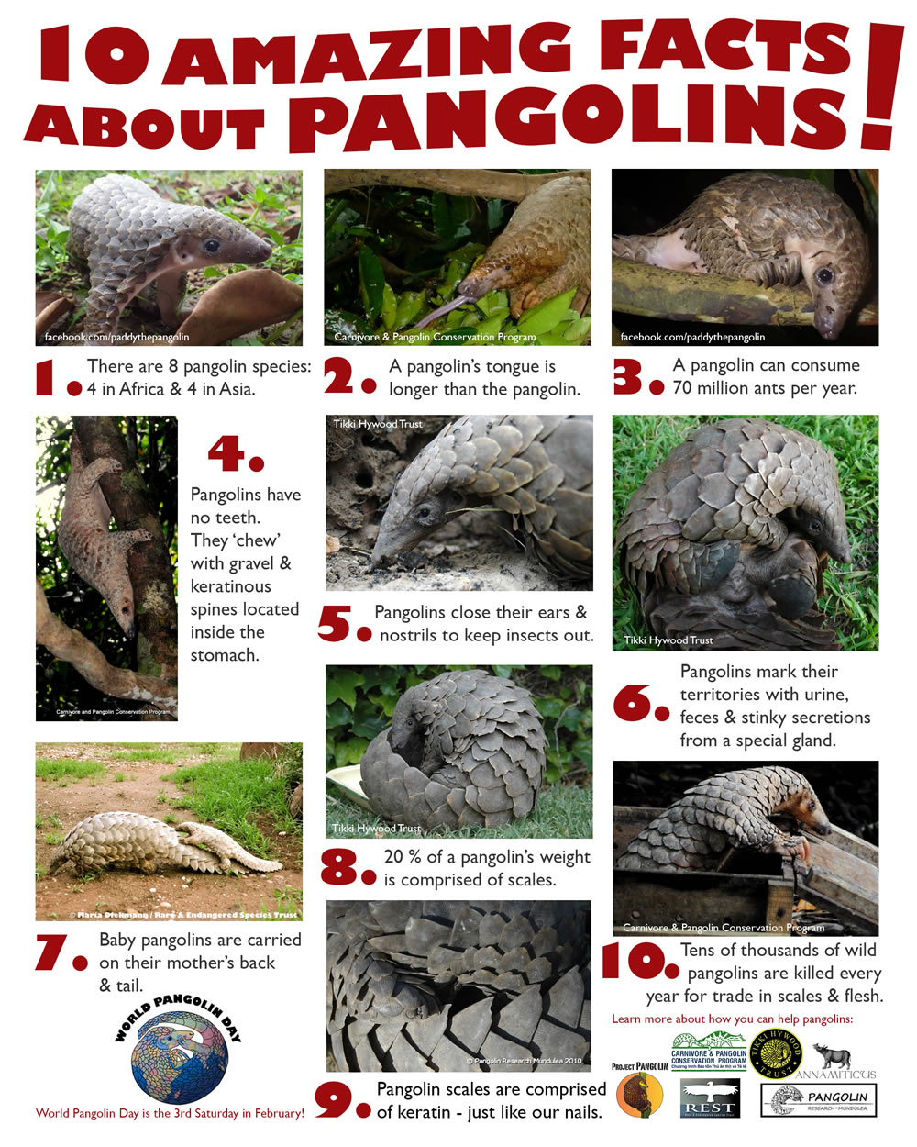

Species of pangolins:

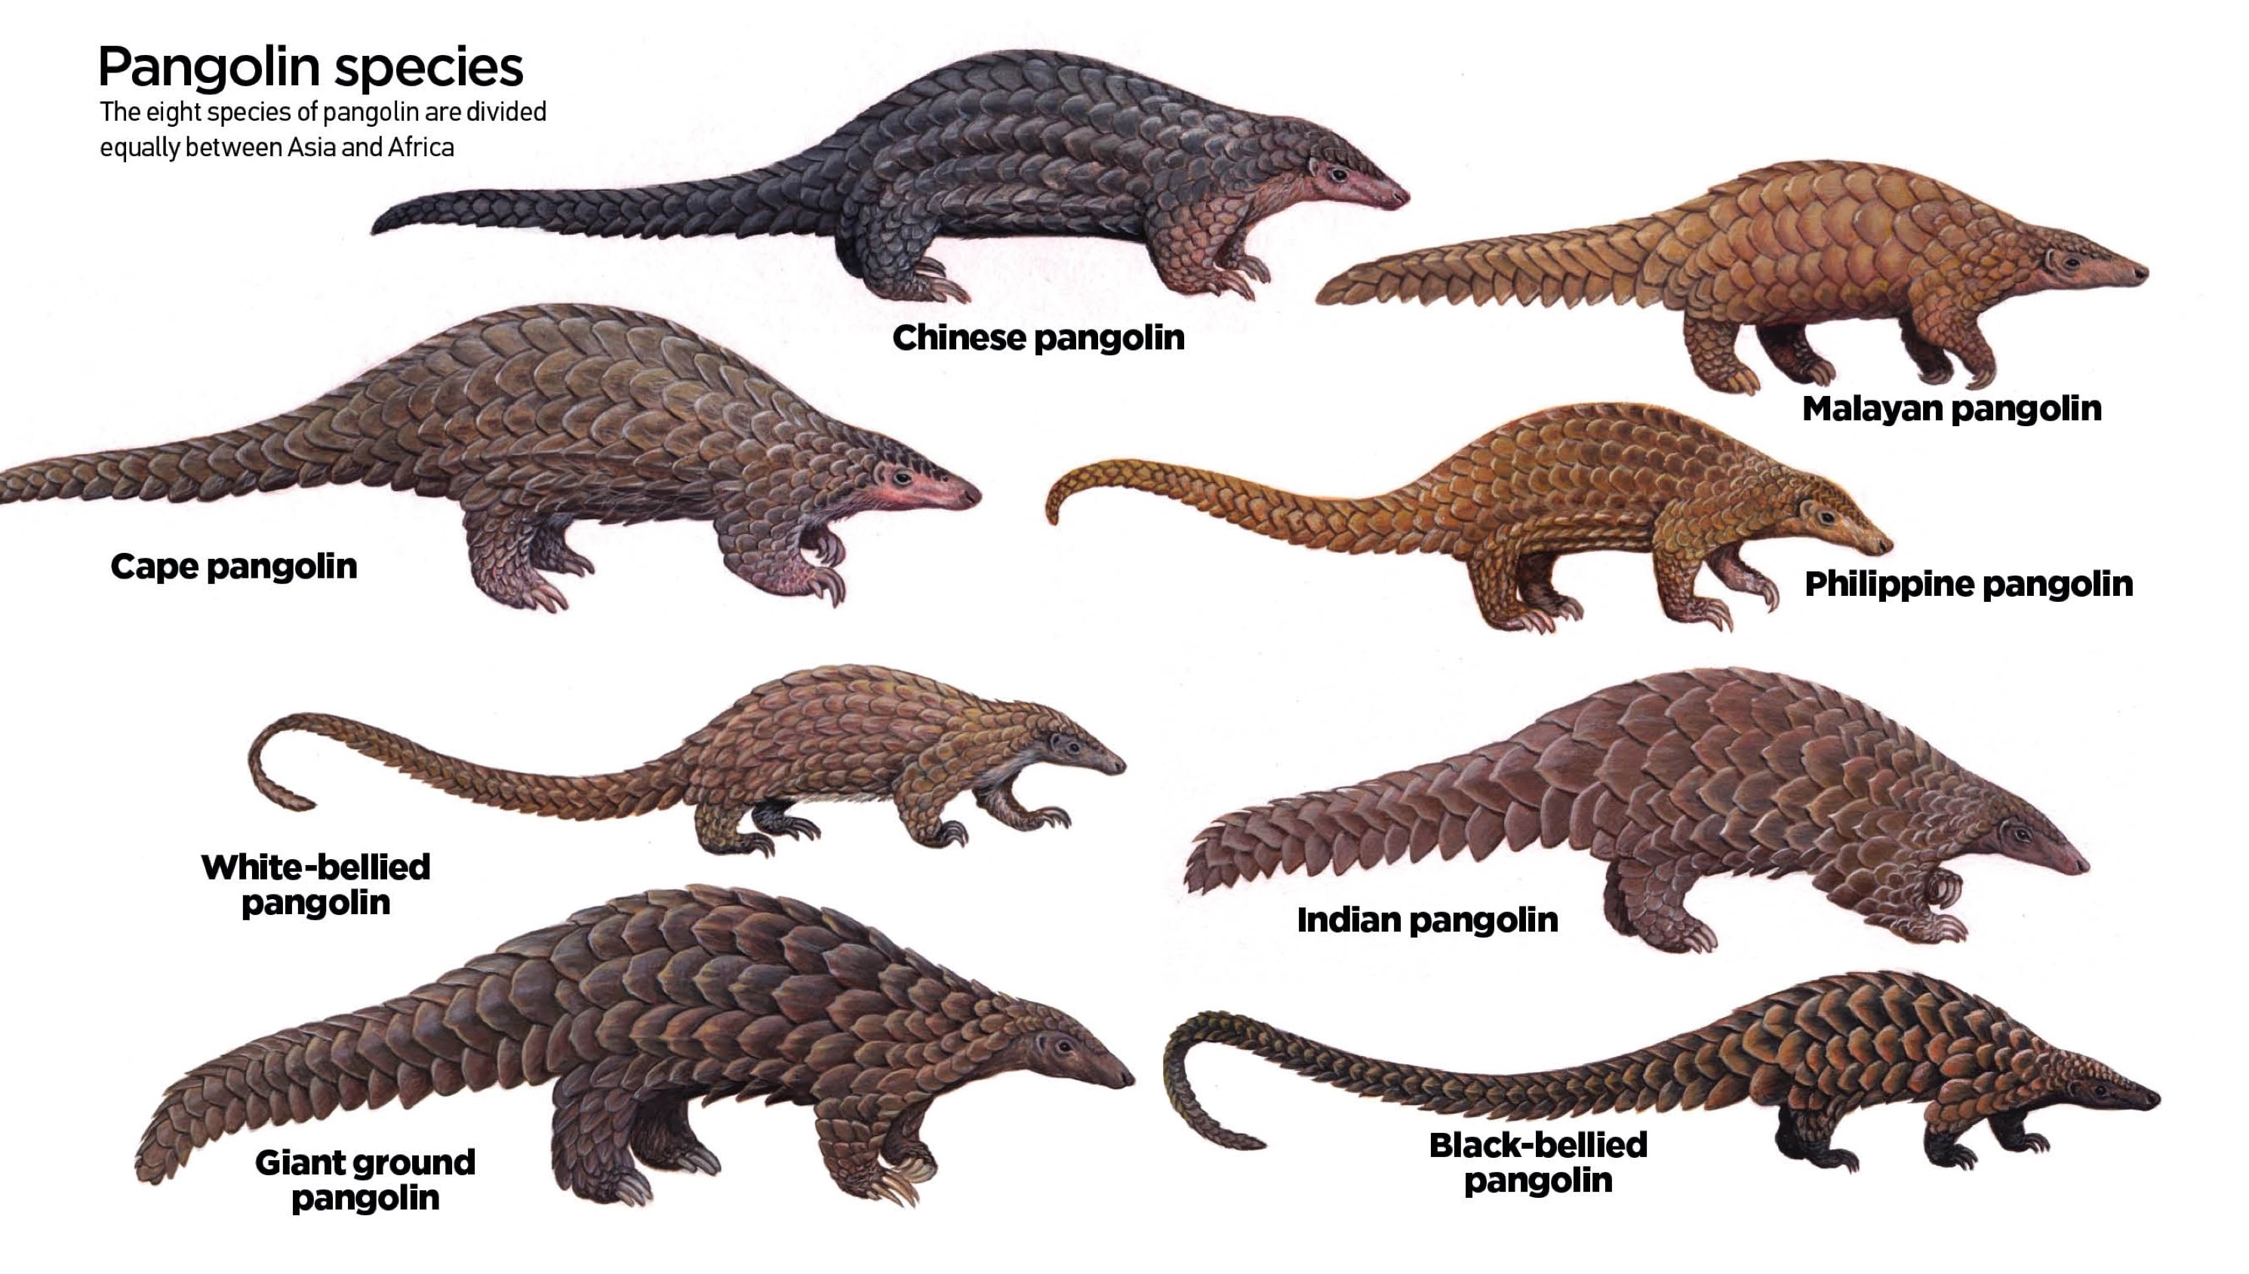

Sources of endangered
pangolins:
https://www.pangolins.org/

https://www.worldanimalprotection.org/news/pangolin-poaching-brutal-reality

https://news.detik.com/berita/d-3710174/ini-alasan-trenggiling-di-sumatera-terus-diburu

https://www.worldwildlife.org/species/pangolin
facts about pangolin:

Pangolins are endangered because people kill them to make drugs, shose, hat, medice (in china), and also food.
People know that pangolins almoust extink but people dont care. In Indonesia there is a rule that you cant kill endangered animals or destroy their habitat, its the nomber 5 rule of Indonesia, if someone break this rules they will get a fine of RP.100.000.000 and in jail for 5 years.
So save the endangered animals and dont break their natural habitat, remember that.

