https://sustainabledevelopment.un.org/?menu=1300
Action preparation
we choose number 8 because related with our topic
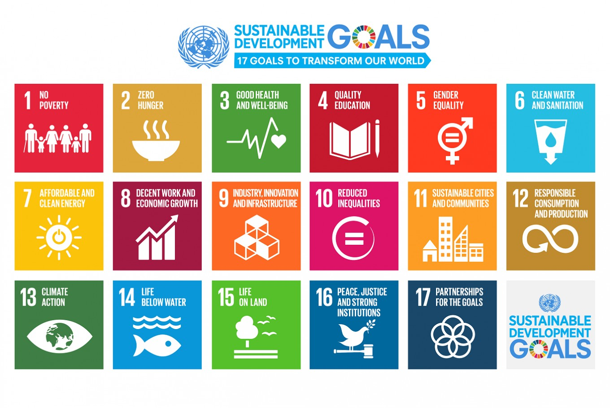

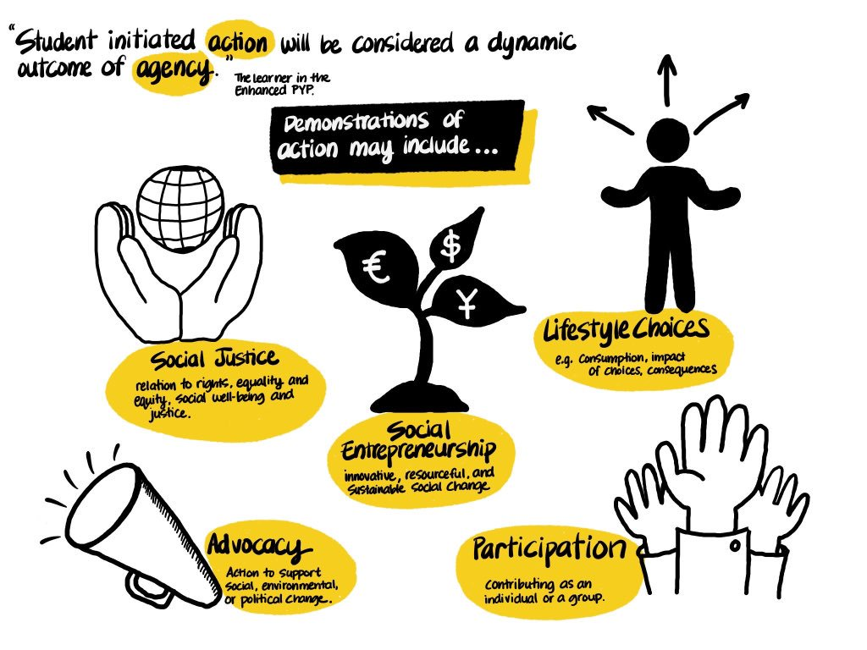
Type of action is social justice.

Here is the detail
What? | Action is the last step in IB learning activity.
Who? | we as the students of grade 5 will do action and mentor guide and supervise mentees. We will invite our guest speaker from Pertamina and BUMN. Also grade 3-8 to listen our presentation in our seminar/workshop
When? | Insya Allah we will held on Tuesday, 17 March 2020
Where? | Auditorium of Al Jabr
Why? | Because the last step of our learning journey. Also, using scientific method
How? | Seminar / workshop about Pertamina and BUMN. Prepare slide for presentation. Prepare souvenir for audience. Create game board for audience. Call the experts and make sure they will come. Prepare plan B.

